**Assignment -4**

**Docker and kubernetes**

|  |  |
| --- | --- |
| Assignment Date | 10 October 2022 |
| Student Name | A. Herilson Albert |
| Student Roll Number | 960519104030 |
| Maximum Marks | 2 Marks |

**Question-1:**

**pull an image from docker hub and run it in docker playground.**

1. **pull an image form docker hub**

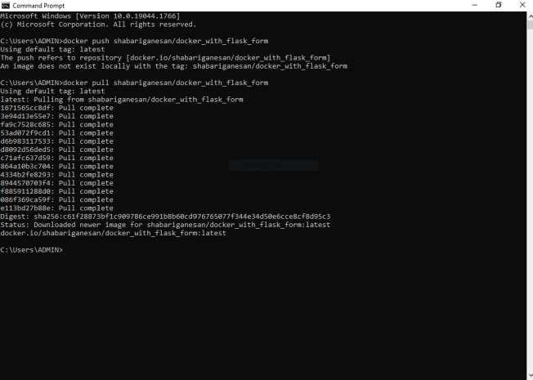

1. **runt it in docker playground**

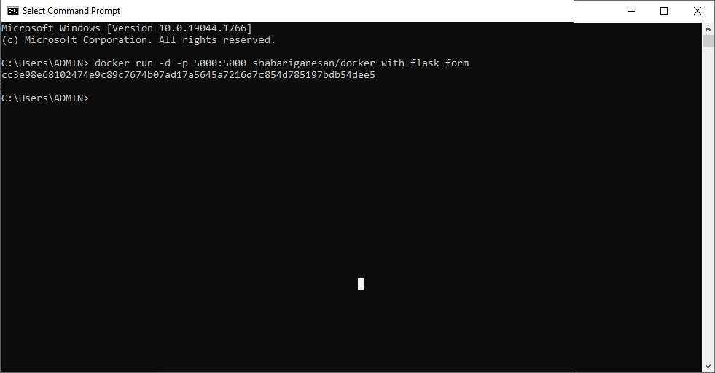  
  
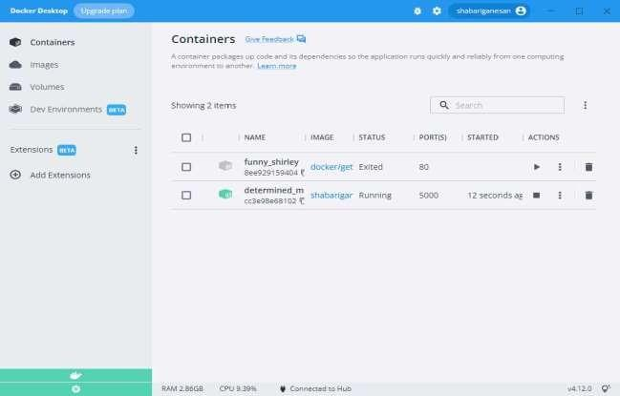

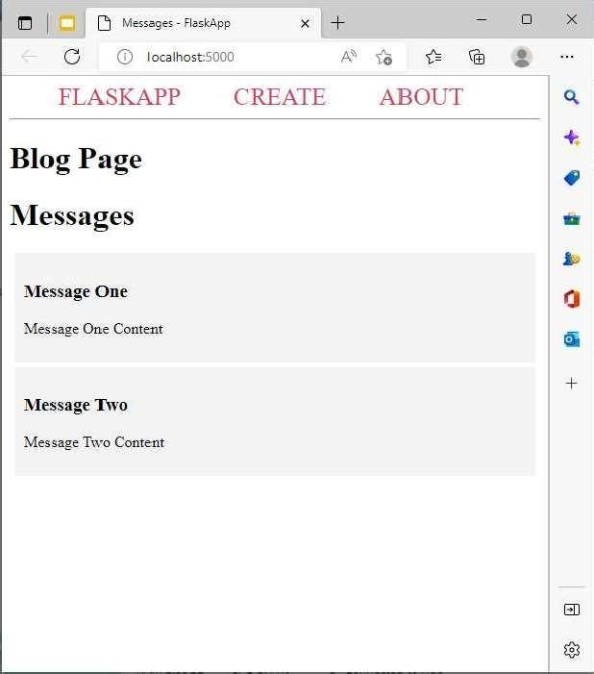

**Question-2:**

**Create a docker file for the jobportal application and deploy it in docker application.**

1. **Creating a docker file for the jobportal application**

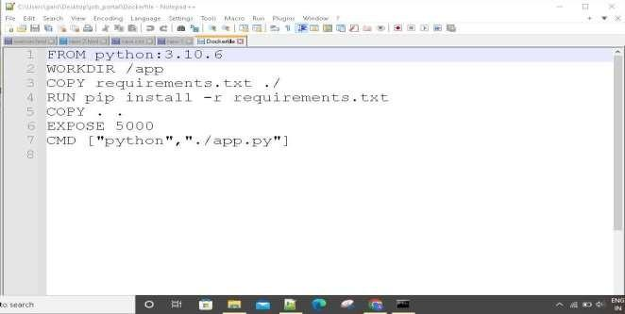

1. **deploy in in dokcer application**

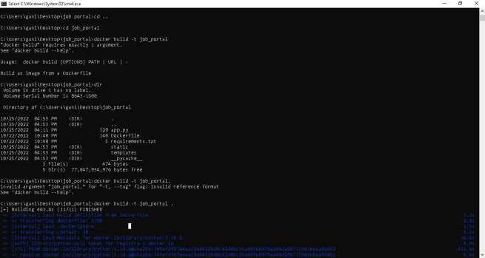

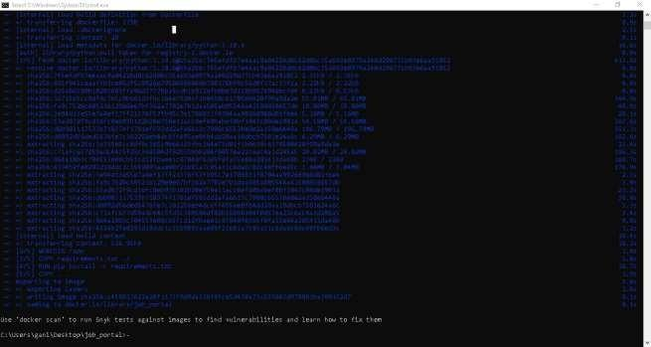

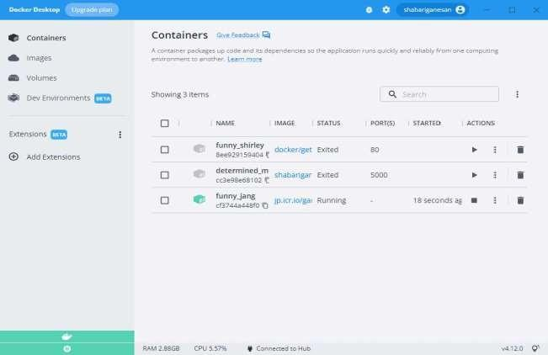

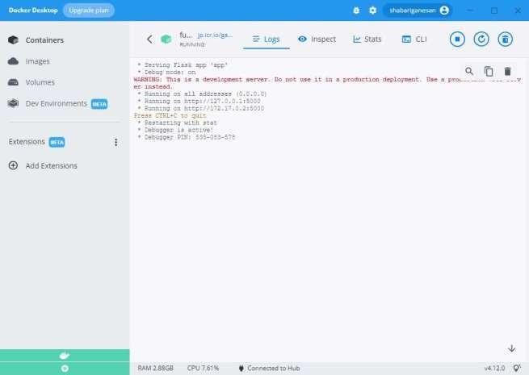

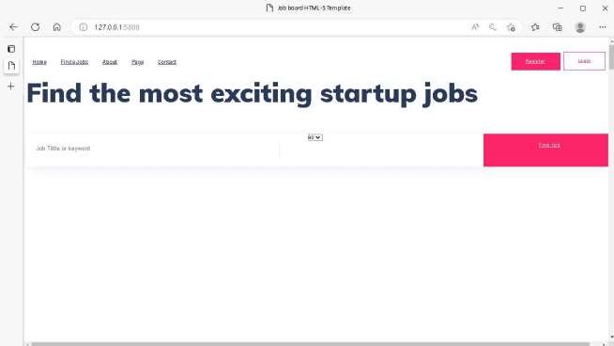

**running in docker desktop 1**

**Question-3:Create aIbm container registry and deploy helloworld app or jobportalapp**

1. **create a ibm container registry**

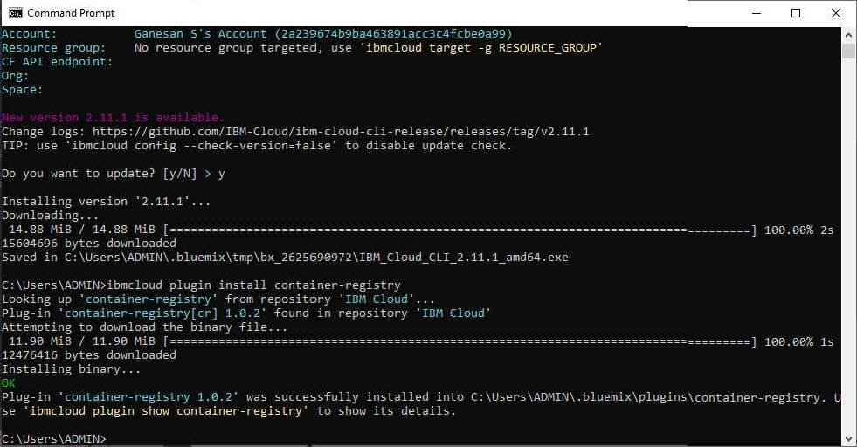

1. **deployhelloworld or jobportal**

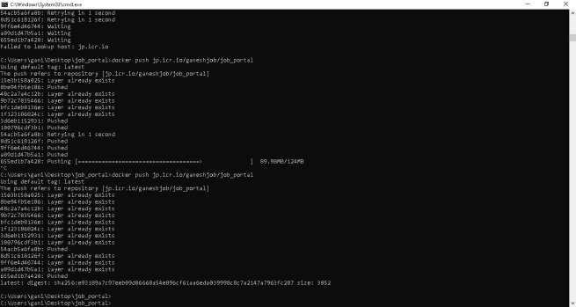

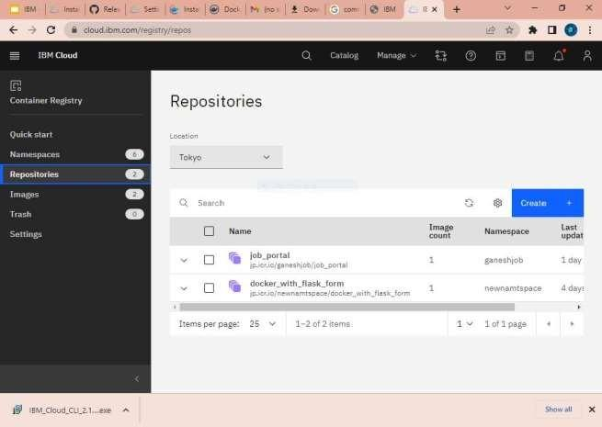

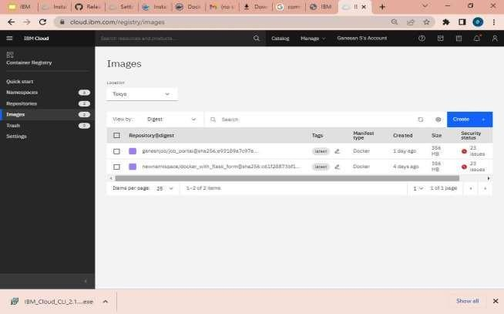

**Question-4: Create a kubernetes cluster in ibm cloud and deploy helloworld image or jobportal image and also expose the same app to run in noteport**

1. **Creating a kubernetes cluster in ibm cloud**

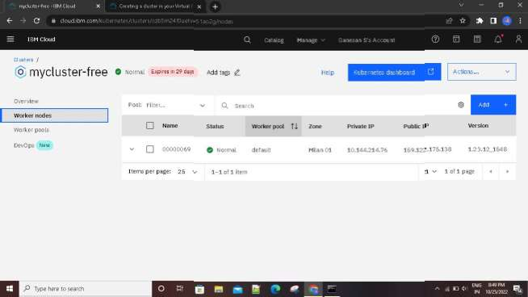

1. **deploy helloworld image or jobportal image and also expose the same app to run in noteport**

